**Visual Programming**

**Lab Journal - Lab 12**

Name: _________________________________

Enrollment #: _________________________________

Class/Section: _________________________________

**Objective**

The Objective of this lab are to understand the following concepts

* Graphics Objects
* Mouse and Keyboard interaction
* Multiple Document Interface

**Task 1 :**

Implement the following exercises.

**Exercise 1**

|  |
| --- |
| Write a program that implements the Illustration given below    Draw the Circle, Ellipse, Line Rectangle etc from Combo Box. E.g if the user select line in the combo box then line should draw on the windows form client area and so on.  Hint : Use selected index change event of combo box. |

**Source Code :**

**Form1.cs :**

using System;

using System.Collections.Generic;

using System.ComponentModel;

using System.Data;

using System.Drawing;

using System.Linq;

using System.Text;

using System.Threading.Tasks;

using System.Windows.Forms;

namespace vplab12

{

public partial class Form1 : Form

{

public Form1()

{

InitializeComponent();

}

private void button1_Click(object sender, EventArgs e)

{

Graphics obj = this.CreateGraphics();

Point p1 = new Point(10, 10);

Point p2 = new Point(50, 50);

Pen p = new Pen(Color.Black, 8);

obj.DrawLine(p, p1, p2);

Rectangle rect = new Rectangle();

obj.DrawRectangle(p, rect);

}

private void comboBox1_SelectedIndexChanged(object sender, EventArgs e)

{

Graphics obj = this.CreateGraphics();

if (comboBox1.SelectedIndex == 0)

{

this.Refresh();

Point p1 = new Point(10, 10);

Point p2 = new Point(50, 50);

Pen p = new Pen(Color.Black, 4);

Rectangle rect = new Rectangle(150, 100, 100, 100);

obj.DrawEllipse(p, rect);

}

else if (comboBox1.SelectedIndex == 1)

{

this.Refresh();

Point p1 = new Point(10, 10);

Point p2 = new Point(50, 50);

Pen p = new Pen(Color.Black, 4);

Rectangle rect = new Rectangle(150, 100, 100, 70);

obj.DrawEllipse(p, rect);

}

else if (comboBox1.SelectedIndex == 2)

{

this.Refresh();

Point p1 = new Point(10, 10);

Point p2 = new Point(50, 50);

Pen p = new Pen(Color.Black, 4);

Rectangle rect = new Rectangle(150, 100, 100, 70);

obj.DrawRectangle(p, rect);

}

}

}

}

**Screenshot :**

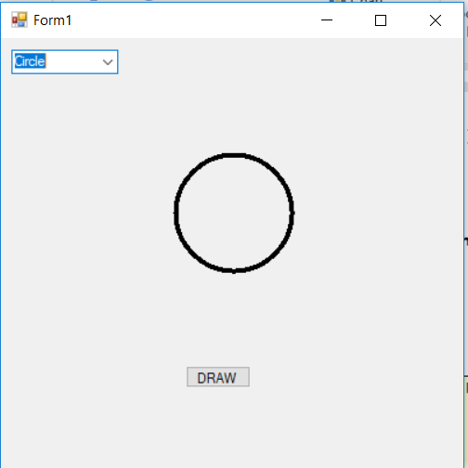

**Exercise 2**

|  |
| --- |
| Write a Program that implements the illustration given below    Hint : Use the **mouse move**, **mouse down, mouse up** events of the form. |

**Exercise 3**

|  |
| --- |
| Create a form with the menu strip like the one shown in the picture such that when the user click the pink background form, a form opens with the name : Pink Form and its background colour is pink. |

**Exercise 4**

|  |
| --- |
| Write a program that implements the design given below using Graphics and drawing |

**Source Code :**

using System;

using System.Collections.Generic;

using System.ComponentModel;

using System.Data;

using System.Drawing;

using System.Linq;

using System.Text;

using System.Threading.Tasks;

using System.Windows.Forms;

namespace VP_LAB_12_TASK__

{

public partial class Form1 : Form

{

public Form1()

{

InitializeComponent();

}

private void Form1_Load(object sender, EventArgs e)

{

}

private void button1_Click(object sender, EventArgs e)

{

Graphics obj = this.CreateGraphics();

Rectangle rect1 = new Rectangle(150, 100, 100, 100);

Pen p1 = new Pen(Color.Blue, 4);

obj.DrawEllipse(p1, rect1);

Rectangle rect2 = new Rectangle(270, 100, 100, 100);

Pen p2 = new Pen(Color.Black, 4);

obj.DrawEllipse(p2, rect2);

Rectangle rect3 = new Rectangle(390, 100, 100, 100);

Pen p3 = new Pen(Color.Red, 4);

obj.DrawEllipse(p3, rect3);

Rectangle rect4 = new Rectangle(210, 150, 100, 100);

Pen p4 = new Pen(Color.Yellow, 4);

obj.DrawEllipse(p4, rect4);

Rectangle rect5 = new Rectangle(330, 150, 100, 100);

Pen p5 = new Pen(Color.Green, 4);

obj.DrawEllipse(p5, rect5);

}

}

}

**Screenshot :**

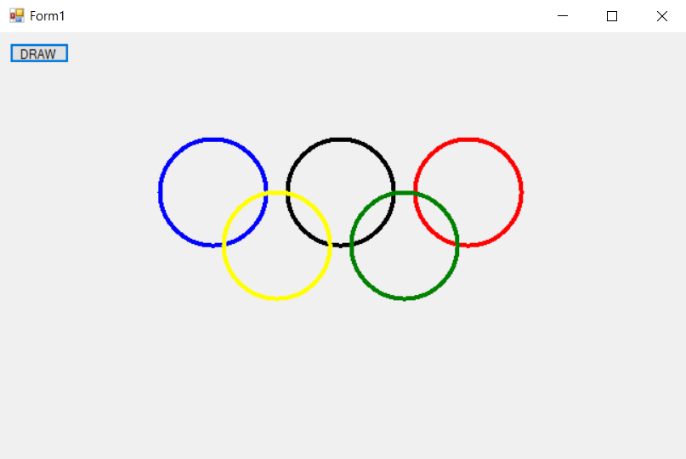

**Implement the given exercises and get them checked by your instructor. If you are unable to complete the tasks in the lab session, deposit this journal alongwith your programs (printed or handwritten) before the start of the next lab session.**

|  |  |  |
| --- | --- | --- |
| **S No.** | **Exercise** | **Checked By:** |
| 1. | Exercise 1 |  |
| 2. | Exercise 2 |  |
| 3. | Exercise 3 |  |

+++++++++++++++++++++++++